Scripps Ranch High School
Modern World History
2018-2019

Teacher:
Mr. Brian Keiser
Room B-6
(858) 621-9020 ext. 3006
bkeiser@sandi.net

Text:
Modern World History: Patterns of Interaction, McDougal Littel

Course Description:
The Modern World History course will investigate themes of power and authority, religious and ethical systems, revolution, economics, cultural interaction, empire building, and science and technology. The rise of democratic ideals will be traced and an understanding of the historical roots of current world issues will be analyzed. The class will cover the origins of democracy and the beginnings of the modern world, the French Revolution, the Industrial Revolution, Imperialism, World War I, World War II, the Cold War, and finally the past and present history of the Middle East.

Skill Development:
In order to become an effective citizen, students must think critically. The students will be exposed to the following critical thinking skills: problem solving, analyzing, cause and effect, cooperative group work, identifying central issues, making comparisons, formulating appropriate questions, distinguishing fact from opinion, recognizing bias and values, drawing conclusions, identifying alternatives, and developing a frame of reference.

Classroom Procedure:
Students are expected to be on time to class and to behave in a responsible manner so that everyone can learn. The category of behavior specifically includes the courteous treatment of everyone at Scripps Ranch High School – students, faculty, and staff alike. Disruptive behavior will not be tolerated as it hinders others in their pursuit of an education. Talking at times can be stimulating and rewarding, at other times it is rude and discourteous. Each student will respect the rights of others to learn in an environment that promotes success and achievement. Students must not wear hats inside the classroom, electronic devices must be turned off and out of sight, and all students must follow the established school rules. Students should come prepared for each class meeting.

Food and Drink Policy
Bottled water is allowed in class; other drinks, candy, and food, are not permitted in class.

Homework Policy:
In general, late work will be accepted until the end of the unit, but will receive 50% of the score it would have earned had it been submitted on time. Essays and some other specific long term assignments may not be submitted late. Excuses such as “a computer virus ate my homework” and “my printer ran out of ink” will not earn you an extension. Tragically, a computer pandemic of epic proportions always breaks out the day before essays are due and those computers not infected inevitably run out of ink or explode. Plan for this in advance; do not wait until the last minute to complete (or not complete) assignments.

Attendance Policy:
In the event of an excused absence, any work due that day must be turned in on the day you return to class in order to earn full credit. If you miss a quiz or a test you will have one week from your return to make it up. If not, your score will be permanently recorded as a zero. It is your responsibility to arrange with me to make up the quiz or test; do not expect me to remind you.

If you are absent you should check the course website and download any missing handouts. Anything not available online is available from me before or after school or during lunch. If you are planning to be absent please come beforehand to receive assignments for that time period.

Written assignments given as homework must be typed and follow MLA format to receive credit unless space is provided on the handout for your answers. See the MLA Style Guide for more information.

Academic Honesty:
Cheating, which includes plagiarism, copying from another student, or allowing someone to copy, will result in a score of “0” for all students participating in the dishonest action. In addition, cheating will result in a feeling of distrust between the student and the teacher. Work that is assigned as individual work is expected to be done independently.

Organization:
Over the course of the year you will receive a great deal of paperwork; having all of your materials organized and readily accessible will be invaluable for studying. Time will occasionally be set aside in class to help you stay organized. Further information will be provided throughout the course.

Grading Breakdown:
90-100 = A
80-89 = B
70-79 = C
60-69 = D
* Students who score below 60% will receive an “F” in this class *

Grading Policy:
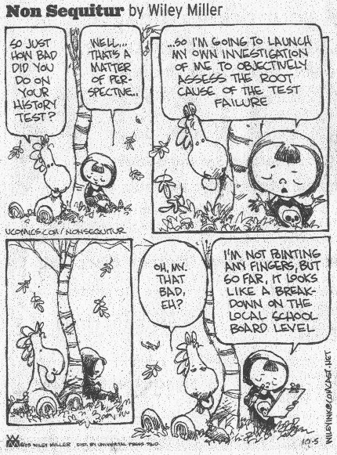
All grades are based upon total points and will largely be determined by scores on quizzes, tests, projects, and essays,

This course is cumulative; you will be expected to know all the material we have covered throughout the course of the year. Your unit exams and weekly quizzes will reflect that expectation.

Extra credit opportunities may occasionally be offered. Students should take advantage of these opportunities when presented. Individualized extra credit assignments will not be given at other times.

The Constitution of the State of California requires that we provide a public education to you free of charge. Your right to a free education is for all school/educational activities, whether curricular or extracurricular, and whether you get a grade for the activity or class. Subject to certain exceptions, your right to a free public education means that we cannot require you or your family to purchase materials, supplies, equipment or uniforms for any school activity, nor can we require you or your family to pay security deposits for access, participation, materials, or equipment. You may be required to attend a fundraising event; however, if you are unable to raise funds for the event, you will not be prevented from participating in an educational activity. Please see the current student handbook at www.srhsfalcons.org regarding the right to a free public education

Student/Parent/Guardian Acknowledgment:
I have read and understood the course description and expectations.

___________________________________
Printed Name of Student

___________________________________ __________________
Student Signature Date

___________________________________ __________________
Parent/Guardian Signature Date

___________________________________ __________________
Parent e-mail Phone

